**Artificial Intelligence Practical File**

**2021-2022**

**VI Semester**

**Name: Akanksha goel**

**Examination Roll No.: 19035570011**

**College Roll No.: 0726**

**Course.: B.Sc. (Hons) Computer Science**

**Section.: A**

**1.Write a prolog program to calculate the sum of two numbers.**

/*sum(X,Y,R):- R is X+Y.

*/

sum :-

write('Enter 1st number : '),

read(X),

write('Enter 2nd number : '),

read(Y),

Z is X+Y,

write('Sum of '),write(X),write(' and '),write(Y),write(' is '),write(Z),nl,

write('Do you want to add more numbers (yes/no) : '),

read(Ch),

cont(Ch).

cont(yes) :- sum.

cont(no) :- !.

cont(Ch) :- write('Sorry, you entered wrong choice !'),!.

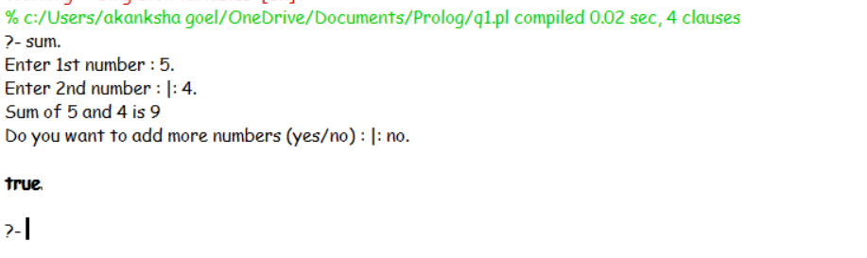

**2.Write a Prolog program to implement max(X, Y, M) so that M is the maximum of two numbers X and Y.**

/* max(X,Y,M):- M is X, X>=Y.

max(X,Y,M):- M is Y, X<Y. */

input :-

write('Enter 1st number : '),

read(X),

write('Enter 2nd number : '),

read(Y),

max(X,Y,M).

max(X,Y,M):-

M is X, X>=Y,

output(X,Y,M).

max(X,Y,M):-

M is Y, X<Y,

output(X,Y,M).

output(X,Y,M) :-

write('Maximum of '),write(X),write(' and '),write(Y),write(' is '),write(M),nl,

write('Do you want to continue ? (yes/no) : '),

read(Ch),

cont(Ch).

cont(yes) :- input.

cont(no) :- !.

cont(Ch) :- write('Sorry, you entered wrong choice !'),!.

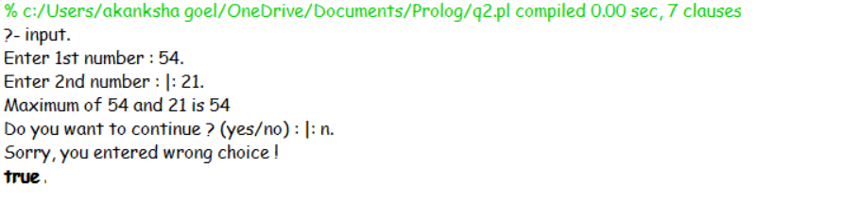

**3.Write a program in PROLOG to implement factorial (N, F) where F represents the factorial of a number N.**

/*factorial(0,1).

factorial(N,R):-N>0,N1 is N-1,factorial(N1,Res),R is N*Res.

*/

input :-

write('Enter the number : '),

read(N),

factorial(N,R),

output(N,R).

factorial(0,1).

factorial(N,R):-N>0,N1 is N-1,factorial(N1,Res),R is N*Res.

output(N,R) :-

write('Factorial of '),write(N),write(' is '),write(R),nl,

write('Do you want to continue ? (yes/no) : '),

read(Ch),

cont(Ch).

cont(yes) :- input.

cont(no) :- !.

cont(Ch) :- write('Sorry, you entered wrong choice !'),!.

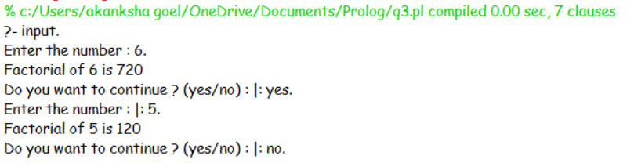

**4.Write a program in PROLOG to implement generate_fib(N,T) where T represents the Nth term of the fibonacci series.**

/*generate_fib(1,0).

generate_fib(2,1).

generate_fib(N,T):-N>2,N1 is N-1,N2 is N-2,generate_fib(N1,T1),generate_fib(N2,T2),T is T1+T2.

*/

input :-

write('Enter the value of N (Nth term) : '),

read(N),

generate_fib(N,T),

output(N,T).

generate_fib(1,0).

generate_fib(2,1).

generate_fib(N,T):-N>2,N1 is N-1,N2 is N-2,generate_fib(N1,T1),generate_fib(N2,T2),T is T1+T2.

output(N,T) :-

nl,write(N),write('th term of fibonacci series : '),write(T),nl,nl,

write('Do you want to continue ? (yes/no) : '),

read(Ch),

cont(Ch).

cont(yes) :- input.

cont(no) :- !.

cont(Ch) :- write('Sorry, you entered wrong choice !'),!.

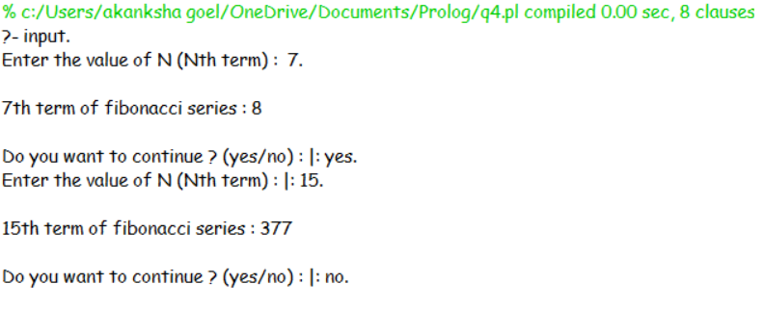

**5.Write a Prolog program to implement GCD of two numbers.**

/*

gcd(0, X, X) :-!.

gcd(X, 0, X) :-!.

gcd(X, X, X) :-!.

gcd(M, N, X) :- N>M, Y is N-M, gcd(M, Y, X).

gcd(M, N, X) :- N<M, Y is M-N, gcd(Y, N, X).

gcd(X,0,X).

gcd(X,Y,G) :-

R is mod(X,Y),

gcd(Y,R,G).

*/

input :-

write('Enter 1st number : '),

read(X),

write('Enter 2nd number : '),

read(Y),

gcd(X,Y,G),

output(X,Y,G).

gcd(0, X, X) :-!.

gcd(X, 0, X) :-!.

gcd(X, X, X) :-!.

gcd(M, N, X) :- N>M, Y is N-M, gcd(M, Y, X).

gcd(M, N, X) :- N<M, Y is M-N, gcd(Y, N, X).

/*gcd(X,0,X).

gcd(X,Y,G) :-

R is mod(X,Y),

gcd(Y,R,G).

*/

output(X,Y,G) :-

write('GCD of '),write(X),write(' and '),write(Y),write(' is '),write(G),nl,

write('Do you want to continue ? (yes/no) : '),

read(Ch),

cont(Ch).

cont(yes) :- input.

cont(no) :- !.

cont(Ch) :- write('Sorry, you entered wrong choice !'),!.

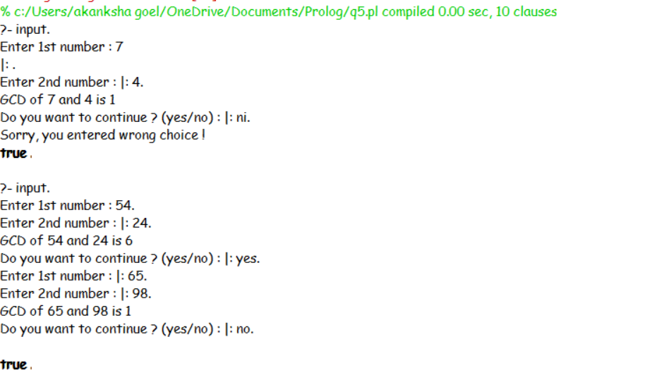

**6.Write a Prolog program to implement power (Num ,Pow, Ans) : where Num is raised to the power Pow to get Ans.**

/*power(Num,Pow,Ans):-Ans is Num**Pow.*/

power :-

write('Enter Number : '),

read(X),

write('Enter Power : '),

read(Y),

Z is X**Y,

write(X),write(' to the power '),write(Y),write(' is '),write(Z),nl,

write('Do you want to continue ? (yes/no) : '),

read(Ch),

cont(Ch).

cont(yes) :- power.

cont(no) :- !.

cont(Ch) :- write('Sorry, you entered wrong choice !'),!.

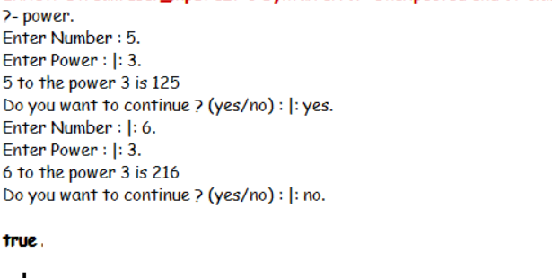

**7.Prolog program to implement multi (N1, N2, R) : where N1 and N2 denotes the numbers to be multiplied and R represents the result**

/* multi(N1, N2, R):-R is N1 * N2.*/

multi :-

write('Enter 1st number : '),

read(X),

write('Enter 2nd number : '),

read(Y),

Z is X*Y,

write('Product of '),write(X),write(' and '),write(Y),write(' is '),write(Z),nl,

write('Do you want to continue ? (yes/no) : '),

read(Ch),

cont(Ch).

cont(yes) :- multi.

cont(no) :- !.

cont(Ch) :- write('Sorry, you entered wrong choice !'),!.

